Great Barrier Island Kākāriki Project

Follow up report on
Stage One: Nest Searching in the Okiwi Valley Area
February 2018

Department of Conservation Land

Serena Simmonds
Institute of Natural and Mathematical Sciences
Massey University
Auckland, New Zealand
serena.simmonds17@gmail.com

In December 2017 the first stage of the Okiwi Valley Kākāriki project commenced. The areas that were searched for kakariki (Cyanoramphus novaezelandiae) nests in during this time included council land and private property, with a small area of the Department of Conservation (D.o.C) land adjacent to the D.o.C office in Okiwi searched also. To ensure that all areas in the Okiwi River Valley were searched for nests a section of forest opposite the D.o.C office was searched in February 2018. This nest search took place on the 10th and 11th of February, 2018 and followed the same methods as the previous search. For more details on the methodology please refer to the December 2017 report ‘Stage One: Nest Searching in the Okiwi Valley Area’. The weather over the two days that were spent searching for nests was overcast with low cloud, rain at times and minimal wind.
Area Searched
The area that was searched for nests during this visit can be located in the eastern most section of the Okiwi River Valley search area, and is found between the Whangapoua wetlands and Aotea Road (Figure 1). The search area consisted of 13.6 hectares of mature hardwood, open grassland, and Cordyline australis forest. Sections of bush that were predominantly grassy, young regenerating forest, or C. australis bush that fell within this section were not searched as there were no suitable nest trees that grow in this area. A full day was spent searching this area, and half a day was spent searching the Okiwi Reserve next to Te Kura o Okiwi (Okiwi School), re-checking the active nest and potential nest sites in that area.
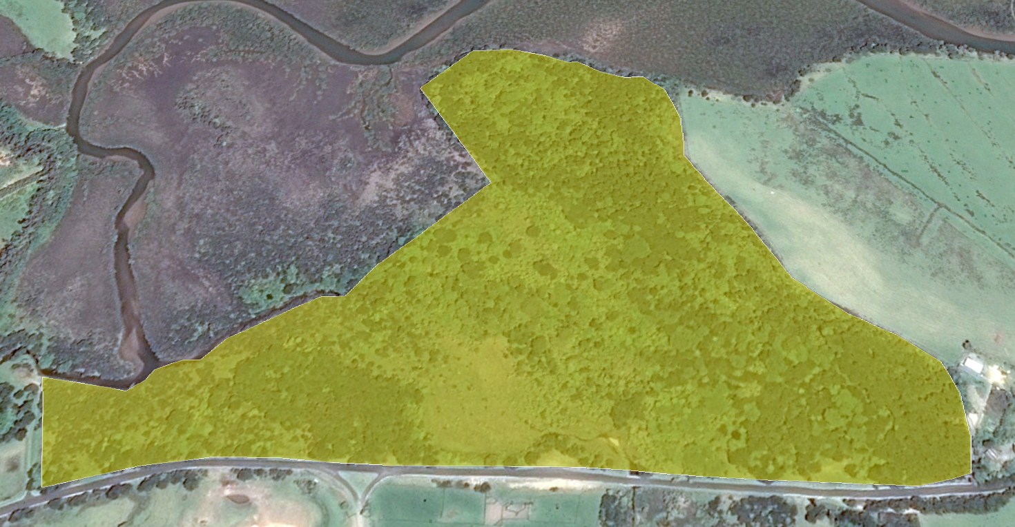
Figure 1. February 2018 search area for kakariki nests highlighted.
Observations
Seven observations of birds were made, with three of those being perched (Figure 2, in green) and four flying (Figure 2, in red). Flock size for the flying observations ranged from one to four (mean=2.25) while flock size for the perched observations had two or three individuals (mean=2.33). One perched observation was near the entrance to the Waterhouse driveway, two perched and three flying observations were in the Okiwi reserve, and one flying observation was in the section of forest that was searched for nests. During this trip kakariki, tui (Prosthemadera novaeseelandiae), and kaka (Nestor meridionalis) were seen displaying aggressive behaviour towards each other in the Okiwi Reserve near the school, mainly around the fruiting puriri (Vitex lucens) and tōtara (Podocarpus totara).
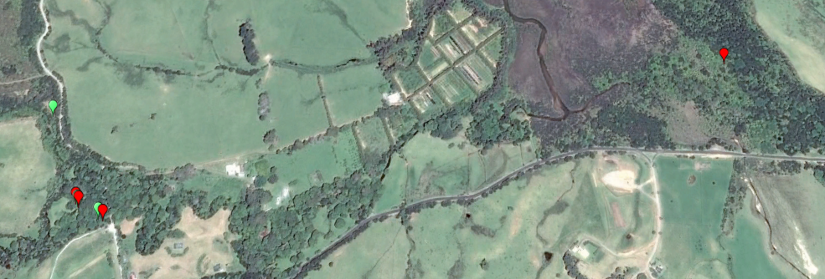
Figure 2. Flying (red) and perched (green) observations of kakariki.
Nests
In this search there were no active nests found, with only 12 potential nest sites identified (Figure 3). These potential nest sites were all found in the central area of this section forest and were in mature puriri trees. All hollows that were at a suitable height were checked for kakariki presence but none was found. Ten of the nest sites had hollows that were too high to check. Each nest site (regardless of hollow height) was observed for up ten minutes to check for bird presence around the site, however no activity was seen in this area.
The area of forest that runs along the north edge, close to the Whangapoua wetlands, is exposed and can experience high wind gusts. Therefore only vegetation that can survive in these conditons is present, such as mānuka (Leptospermum scoparium) and/or kānuka (Kunzea ericoides) scrub. There are no mature puriri trees and hence no nests (potential or otherwise) in the northern area.
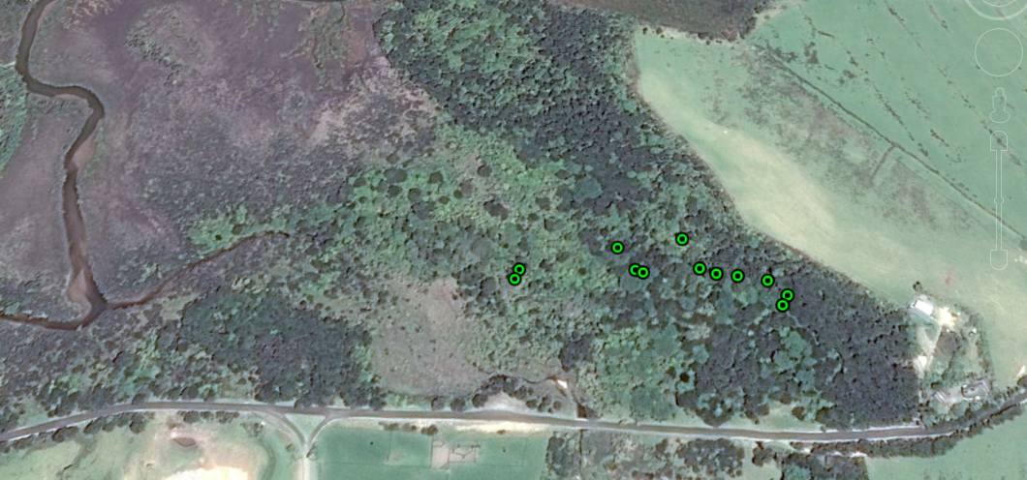
Figure 3. Potential nest sites.
Discussion
While there were no nests found in the area of forest opposite the Department of Conservation office during this visit it does not mean that the kakariki are not using this area as a nesting site. The adverse weather conditions over the search period may have meant that the birds were not as active as they may be at other times of the year, resulting in less sightings. This search identified potential nest sites to review in the future, while identifying the areas of this section of forest that have no potential sites. This means that future nest searches will be less time consuming as a large portion of this forest does not need to be searched.

